Predictive Analytics
PROJECT REPORT
(Project Semester August 2025-Jan 2026)

WEATHER PREDICTION USING MACHINE LEARNING TECHNIQUES

Submitted by

Abel B Varughese
Reg no: 12318150

BTech Computer Science and Engineering
Section- K23BE
INT- 234

Under the Guidance of

Dr. Tanima Thakur- 23532

Discipline of CSE/IT

Lovely School of Computer Science and Engineering

Lovely Professional University, Phagwara

CERTIFICATE

This is to certify that Abel B Varughese bearing Registration no. 12318150 has completed INT 234 project titled, “WEATHER PREDICTION USING MACHINE LEARNING TECHNIQUES” under my guidance and supervision. To the best of my knowledge, the present work is the result of his/her original development, effort and study.

Dr. Tanima Thakur
School of Computer Science and Engineering
Lovely Professional University
Phagwara, Punjab.

Date: 17 Dec 2025

DECLARATION

I, Abel B Varughese, student of BTech under CSE/IT Discipline at Lovely Professional University, Punjab, hereby declare that all the information furnished in this project report is based on my own intensive work and is genuine.

Date: 17 Dec 2025
Registration No: 12318150 Signature
Abel B Varughese

Table of Contents
1. INTRODUCTION 5
1.1 Predictive Analytics Overview 5
1.2 Weather Forecasting and Machine Learning 5
1.3 Problem Statement 5
1.4 Objectives 6
1.5 Scope of the Study 6
2. DATASET DESCRIPTION 6
2.1 Dataset Source 6
2.2 Dataset Structure 7
2.3 Description of Attributes 7
2.4 Nature of Prediction Tasks 8
3. DATA PREPROCESSING 8
3.1 Handling Missing Values 8
3.2 Outlier Handling 9
3.3 Feature Scaling 9
3.4 Class Balancing 10
4. EXPLORATORY DATA ANALYSIS 10
4.1 Temperature Distribution 10
4.2 Correlation Analysis 10
4.3 Feature Relationships 11
5. MODEL DEVELOPMENT 11
5.1 Train–Test Data Splitting 12
5.2 Feature Scaling 12
5.3 Regression Model Development 13
5.4 Classification Model Development 14
5.5 Summary of Model Achievements 16
6. MODEL EVALUATION AND COMPARISON 16
6.1 Purpose of Model Evaluation 17
6.2 Evaluation of Regression Models 17
6.3 Visual Evaluation of Regression Models 19
6.4 Evaluation of Classification Models 20
6.6 Confusion Matrix Analysis 22
6.7 Comparative Analysis of Classification Models 23
6.8 Selection of Best Models 24
6.9 Key Evaluation Insights 24
6.10 Summary 25
7. BEST MODEL IDENTIFICATION AND DISCUSSION 25
7.1 Criteria for Model Selection 25
7.2 Best Model for Regression Task 26
7.3 Best Model for Classification Task 27
7.4 Comparative Summary of Selected Models 28
7.5 Limitations of Selected Models 29
7.6 Key Observations from Model Selection 29
7.7 Final Remarks 29
8. CONCLUSION 29
9. FUTURE SCOPE 31
10.REFERENCES (IEEE STYLE) 32

1. INTRODUCTION

1.1 Predictive Analytics Overview
Predictive analytics refers to the use of historical data, statistical algorithms, and machine learning techniques to predict future outcomes. It transforms raw data into actionable insights by identifying patterns and relationships that are not easily observable through traditional analysis methods. Predictive analytics is widely used in fields such as healthcare, finance, marketing, manufacturing, and environmental sciences.
Machine learning models form the backbone of predictive analytics by learning from historical data and making predictions on unseen data. These models continuously improve as more data becomes available, making them highly effective in dynamic environments such as weather systems.

1.2 Weather Forecasting and Machine Learning
Weather systems are inherently complex and non-linear. Variables such as temperature, humidity, wind speed, pressure, and air quality interact in intricate ways. Traditional forecasting models use physical equations derived from atmospheric science, which require significant computational power and expertise.
Machine learning offers an alternative by learning relationships directly from data without explicit physical modeling. By analyzing large volumes of historical weather data, machine learning models can identify patterns and correlations that enhance prediction accuracy.

1.3 Problem Statement
The objective of this project is to build a predictive system that:
- Estimates temperature values using regression techniques
- Classifies weather conditions using classification algorithms
- Compares multiple models to identify the best-performing approach

1.4 Objectives
- To preprocess and clean real-world weather data
- To perform exploratory data analysis (EDA)
- To implement regression models for temperature prediction
- To implement classification models for weather condition prediction
- To evaluate and compare models using appropriate metrics

1.5 Scope of the Study
This study is limited to supervised machine learning approaches using historical weather datasets. Time-series forecasting, deep learning architectures, and real-time data streaming are not included within the scope of this project.

2. DATASET DESCRIPTION

2.1 Dataset Source
The dataset used in this project is sourced from Kaggle and contains global weather observations collected from multiple locations worldwide. The dataset includes meteorological parameters as well as air-quality measurements.
Dataset link: https://www.kaggle.com/datasets/nelgiriyewithana/global-weather-repository?utm_source=chatgpt.com
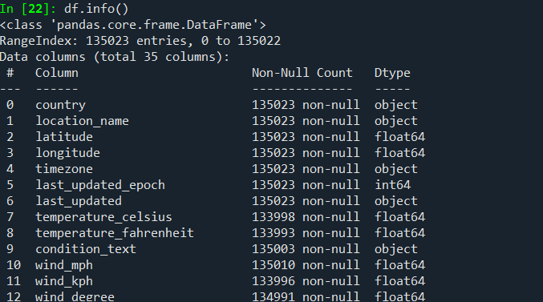

2.2 Dataset Structure
- Total records: ~135,000
- Total attributes: 35
- Data types:
  - Numerical (temperature, humidity, wind speed, pressure)
  - Categorical (country, location, weather condition)

2.3 Description of Attributes
Key attributes include:
- Temperature (Celsius and Fahrenheit)
- Humidity
- Wind speed and direction
- Atmospheric pressure
- Precipitation
- Air quality indices (CO, NO₂, PM2.5, PM10)
- Weather condition description

2.4 Nature of Prediction Tasks
- Regression Task: Predicting continuous temperature values
- Classification Task: Predicting categorical weather conditions

3. DATA PREPROCESSING
Data preprocessing is a crucial step in predictive analytics as real-world datasets often contain inconsistencies, missing values, and noise.

3.1 Handling Missing Values
Missing values were identified across both numerical and categorical features. To ensure data integrity:
- Numerical attributes were imputed using the median, which is robust to skewed distributions.
- Categorical attributes were imputed using the mode to preserve the most frequent category.
This approach prevents data loss while maintaining statistical consistency.
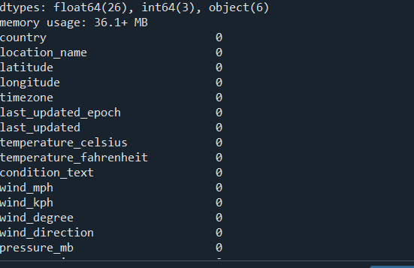

3.2 Outlier Handling
Weather data often contains extreme values representing rare but valid environmental events. Instead of removing these values, a domain-based constraint approach was used. Temperature values were limited to physically realistic bounds (−30°C to 50°C) to prevent erroneous values from influencing model training.

3.3 Feature Scaling
Standardization was applied using the StandardScaler technique to ensure all numerical features contribute equally to model training. Scaling is particularly important for distance-based and linear models.
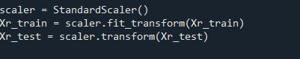

3.4 Class Balancing
For classification, weather condition classes with very low frequencies were filtered to reduce class imbalance. This ensures fair model evaluation and prevents bias toward majority classes.

4. EXPLORATORY DATA ANALYSIS
Exploratory Data Analysis (EDA) was conducted to understand data distribution and relationships between variables.

4.1 Temperature Distribution
A histogram revealed that temperature values follow a near-normal distribution with slight skewness. This supports the use of regression techniques.
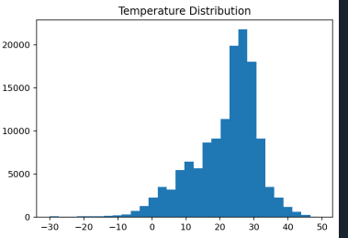

4.2 Correlation Analysis
A correlation heatmap was generated to examine relationships between numerical features. Temperature showed moderate correlation with humidity and wind speed, indicating the presence of both linear and non-linear relationships.
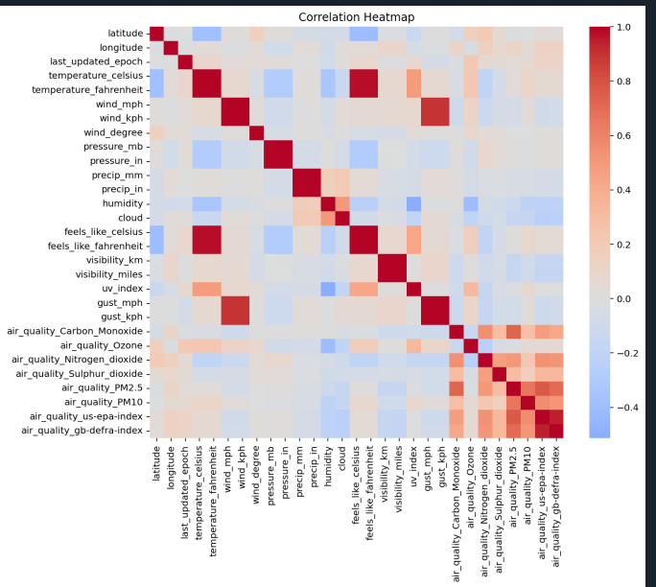

4.3 Feature Relationships
Scatter plots between temperature and humidity, as well as temperature and wind speed, demonstrated non-linear patterns, justifying the use of ensemble and tree-based models.

5. MODEL DEVELOPMENT
Model development is a crucial stage in predictive analytics where suitable machine learning algorithms are selected, trained, and evaluated to achieve accurate predictions. In this project, both regression and classification models were developed to address different predictive objectives using the same weather dataset.

5.1 Train–Test Data Splitting
Before training the models, the dataset was divided into training and testing subsets using an 80:20 split ratio.
- Training Set (80%): Used to train the machine learning models
- Testing Set (20%): Used to evaluate model performance on unseen data
This approach ensures that the models are evaluated fairly and helps prevent overfitting, where a model performs well on training data but poorly on new data.
For the classification task, stratified sampling was applied during splitting to preserve the proportional distribution of weather condition classes in both training and testing sets. This is particularly important in multi-class classification problems where class imbalance may affect evaluation results.

5.2 Feature Scaling
Feature scaling was performed using StandardScaler, which standardizes numerical features by transforming them to have a mean of zero and a standard deviation of one.
Scaling was applied after splitting the dataset to prevent data leakage. The scaler was fitted only on the training data and then applied to the test data.
Feature scaling was necessary because:
- Weather attributes exist on different numerical scales (e.g., pressure vs humidity)
- Linear models such as Linear Regression and Logistic Regression are sensitive to feature magnitudes
- Scaling improves convergence and numerical stability during model training
Tree-based models such as Random Forest and Decision Tree are inherently less sensitive to scaling; however, scaling was retained for consistency across models.

5.3 Regression Model Development
The regression task aimed to predict temperature in Celsius, a continuous variable, using atmospheric and air-quality features.
5.3.1 Linear Regression
Linear Regression was implemented as a baseline regression model. It assumes a linear relationship between independent variables and the target variable.
Purpose of using Linear Regression:
- To establish a reference performance level
- To assess whether weather variables show linear dependency with temperature
- To provide interpretability and simplicity
Outcome:
- The model achieved a high R² score, indicating that a significant portion of temperature variation could be explained using linear relationships.
- However, higher error values (MAE and RMSE) compared to advanced models suggested that linear assumptions were insufficient to fully capture weather dynamics.
This result highlighted the presence of non-linear interactions between weather features.

5.3.2 Random Forest Regressor
Random Forest Regression was implemented to overcome the limitations of linear models. It is an ensemble learning technique that combines multiple decision trees to improve predictive performance and generalization.
Advantages of Random Forest for this dataset:
- Captures complex non-linear relationships
- Robust to outliers and noise
- Handles feature interactions effectively
- Reduces overfitting through averaging
Outcome:
- Random Forest achieved the lowest MAE and RMSE among regression models.
- It produced the highest R² score, indicating superior predictive accuracy.
- The actual vs predicted temperature plot showed strong alignment, confirming reliable predictions.
Conclusion for Regression:
Random Forest Regressor outperformed Linear Regression and was selected as the best regression model for temperature prediction.

5.4 Classification Model Development
The classification task aimed to predict weather conditions (such as sunny, cloudy, or rainy) based on numerical weather attributes.
5.4.1 Logistic Regression
Logistic Regression was implemented as a baseline classification model due to its simplicity and interpretability.
Purpose of using Logistic Regression:
- To provide a linear decision boundary
- To establish baseline classification performance
- To evaluate whether weather condition classes are linearly separable
Outcome:
- The model achieved reasonable accuracy and balanced precision and recall.
- However, performance varied across different weather conditions, indicating difficulty in capturing complex decision boundaries.
This suggested that linear classification alone was insufficient for accurately distinguishing all weather categories.

5.4.2 Decision Tree Classifier
Decision Tree Classification was implemented to model non-linear and rule-based relationships in weather data.
Advantages of Decision Trees for weather data:
- Handles non-linear decision boundaries
- Interpretable threshold-based logic
- Naturally suited for categorical prediction
- Robust to feature scaling and outliers
Outcome:
- The Decision Tree achieved higher accuracy and F1-score compared to Logistic Regression.
- The confusion matrix showed improved class separation.
- The model effectively learned threshold-based rules involving humidity, wind speed, and air-quality measures.
Conclusion for Classification:
Decision Tree Classifier demonstrated superior performance and was selected as the best classification model.

5.5 Summary of Model Achievements
Task | Model | Key Achievement
Regression | Linear Regression | Established baseline performance
Regression | Random Forest | Best predictive accuracy and lowest error
Classification | Logistic Regression | Baseline linear classification
Classification | Decision Tree | Best class separation and overall performance

6. MODEL EVALUATION AND COMPARISON
Model evaluation is a critical phase in predictive analytics, as it determines how well a trained model performs on unseen data. In this project, separate evaluation strategies were adopted for regression and classification tasks, based on the nature of the target variables. Appropriate quantitative metrics and visual comparisons were used to ensure fair and meaningful assessment of each model.

6.1 Purpose of Model Evaluation
The primary objectives of model evaluation in this study were:
- To measure the predictive accuracy of each model
- To compare baseline and advanced models
- To identify the most suitable model for regression and classification tasks
- To assess generalization capability on unseen data
Evaluation was performed exclusively on the test dataset, which was not used during model training, ensuring unbiased results.

6.2 Evaluation of Regression Models
The regression task involved predicting temperature in Celsius, a continuous numerical variable. The following standard regression metrics were used for evaluation:
6.2.1 Mean Absolute Error (MAE)
Mean Absolute Error represents the average magnitude of prediction errors, calculated as the mean of absolute differences between actual and predicted values.
- Lower MAE indicates better predictive accuracy
- MAE is easy to interpret, as it is expressed in the same units as the target variable (degrees Celsius)
In this study:
- Linear Regression exhibited higher MAE values
- Random Forest achieved significantly lower MAE, indicating more accurate temperature predictions

6.2.2 Root Mean Squared Error (RMSE)
RMSE measures the square root of the average squared differences between actual and predicted values.
- Penalizes larger errors more strongly than MAE
- Useful for detecting models that make occasional large prediction errors
Results showed that:
- Linear Regression had higher RMSE due to its inability to capture non-linear patterns
- Random Forest achieved lower RMSE, demonstrating greater robustness and consistency

6.2.3 R² Score (Coefficient of Determination)
The R² score indicates the proportion of variance in the target variable explained by the model.
- R² values closer to 1 indicate better model performance
- Helps assess how well the model captures underlying data patterns
In this project:
- Linear Regression achieved a high R² score, confirming the presence of linear relationships
- Random Forest achieved an even higher R² score, indicating superior explanatory power
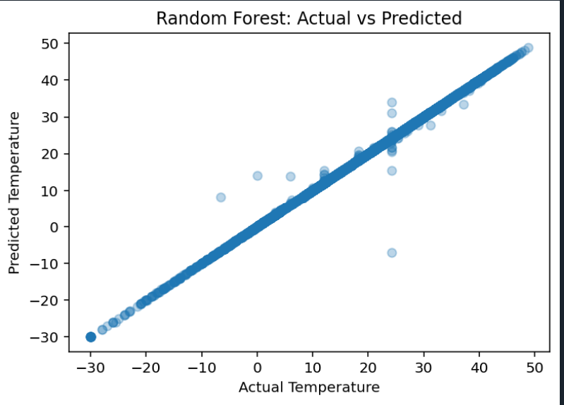

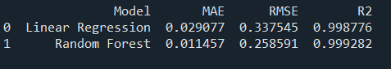

6.3 Visual Evaluation of Regression Models
To complement numerical metrics, visual evaluation techniques were employed.
6.3.1 Model Comparison Using Bar Chart
A bar chart comparing R² scores of regression models was used to visually identify the best-performing model. The chart clearly showed that Random Forest outperformed Linear Regression.
6.3.2 Actual vs Predicted Plot
A scatter plot of actual versus predicted temperature values for the Random Forest model was generated.
- Points clustering near the diagonal line indicate accurate predictions
- Minimal dispersion suggests strong generalization
This visualization confirmed the numerical results and validated the reliability of the Random Forest model.
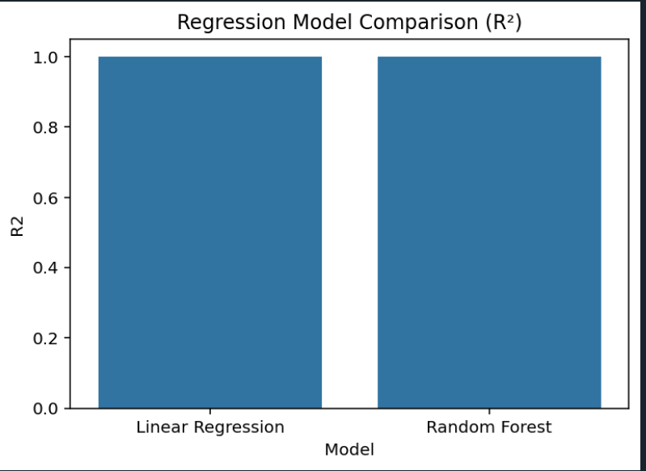

6.4 Evaluation of Classification Models
The classification task involved predicting weather conditions, a multi-class categorical variable. The following metrics were used for evaluation:
6.4.1 Accuracy
Accuracy measures the proportion of correctly classified instances out of the total instances.
- Useful for general performance comparison
- Can be misleading in imbalanced datasets
In this study:
- Both Logistic Regression and Decision Tree achieved reasonable accuracy
- Decision Tree demonstrated higher overall accuracy

6.4.2 Precision
Precision measures the proportion of correct positive predictions among all positive predictions.
- High precision indicates low false positive rates
- Important for reliable class identification
Decision Tree achieved higher precision compared to Logistic Regression, indicating better class-specific prediction quality.

6.4.3 Recall
Recall measures the proportion of actual positive instances correctly identified by the model.
- Reflects the model’s ability to detect relevant instances
- Important when missing a class has significant impact
Decision Tree showed improved recall across most weather conditions.

6.4.4 F1-Score
The F1-score is the harmonic mean of precision and recall.
- Provides a balanced evaluation
- Particularly useful in multi-class and imbalanced datasets
The Decision Tree classifier achieved the highest F1-score, indicating superior balanced performance.

6.5 Classification Report Analysis
The classification report was generated for the final selected classification model (Decision Tree). It provided:
- Per-class precision, recall, and F1-score
- Support values indicating class frequency
This detailed analysis helped identify which weather conditions were predicted more accurately and which classes posed greater challenges.
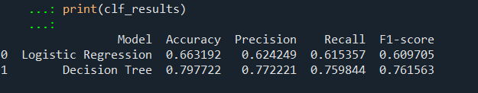

6.6 Confusion Matrix Analysis
A confusion matrix was used to visualize classification performance.
- Diagonal values represent correct predictions
- Off-diagonal values represent misclassifications
The confusion matrix for the Decision Tree classifier showed strong diagonal dominance, indicating accurate classification across most weather conditions.
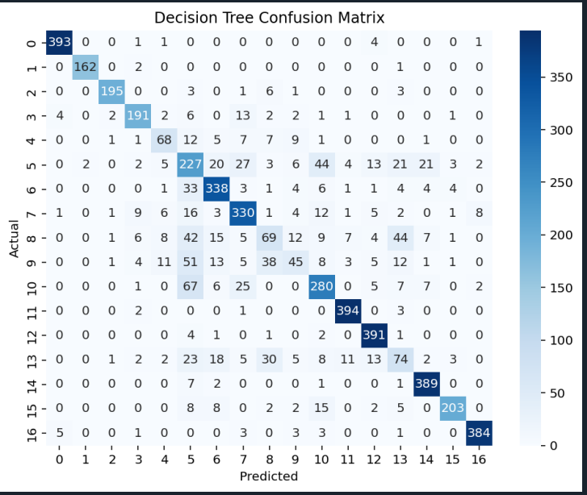

6.7 Comparative Analysis of Classification Models
A bar chart comparing accuracy scores of classification models was used to visually evaluate performance.
- Logistic Regression served as a baseline
- Decision Tree consistently outperformed Logistic Regression across all metrics
This confirmed the importance of non-linear modeling in weather condition classification.

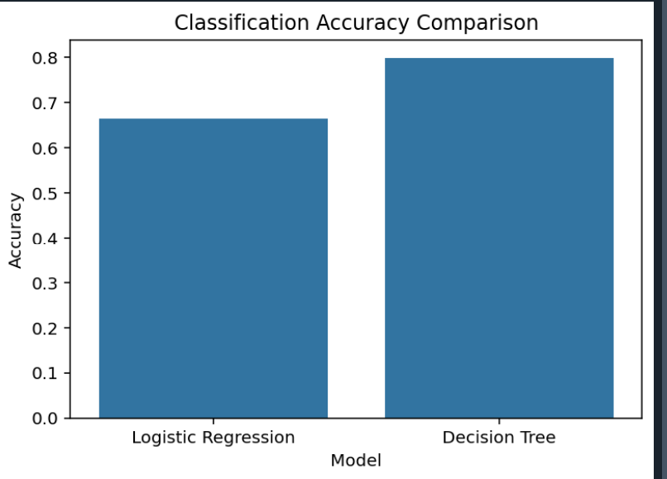

6.8 Selection of Best Models
Based on numerical metrics and visual evaluation:
- Best Regression Model: Random Forest Regressor
  - Lowest MAE and RMSE
  - Highest R² score
- Best Classification Model: Decision Tree Classifier
  - Highest accuracy and F1-score
  - Better class separation

6.9 Key Evaluation Insights
- Linear models provide strong baselines but are limited by linear assumptions
- Ensemble and tree-based models excel in capturing non-linear patterns
- Visual evaluation complements numerical metrics and enhances interpretability
- Proper evaluation ensures reliable and generalizable predictions

6.10 Summary
This evaluation phase demonstrated that advanced machine learning models significantly improve predictive performance in weather analytics. The combined use of numerical metrics and visual analysis enabled a comprehensive comparison and facilitated the selection of optimal models for both regression and classification tasks.

7. BEST MODEL IDENTIFICATION AND DISCUSSION
The objective of this section is to identify the most suitable predictive models for both regression and classification tasks based on systematic evaluation. Model selection was not based on a single metric but on a combination of performance indicators, robustness, interpretability, and suitability to the nature of weather data.

7.1 Criteria for Model Selection
The following criteria were considered while selecting the best-performing models:
- Predictive accuracy on unseen test data
- Error minimization for regression tasks
- Balanced class performance for classification tasks
- Ability to capture non-linear relationships
- Model robustness and generalization capability
Both quantitative metrics and visual evaluations were taken into account to ensure fair and comprehensive comparison.

7.2 Best Model for Regression Task
7.2.1 Selected Model: Random Forest Regressor
After evaluating Linear Regression and Random Forest Regressor, the Random Forest model was selected as the optimal regression model for predicting temperature values.

7.2.2 Justification for Selection
The Random Forest Regressor demonstrated superior performance across all evaluation metrics:
- Achieved the lowest Mean Absolute Error (MAE), indicating reduced average prediction error
- Produced the lowest Root Mean Squared Error (RMSE), showing robustness against large deviations
- Attained the highest R² score, signifying strong explanatory power
In contrast, Linear Regression, while effective as a baseline model, was limited by its assumption of linear relationships between variables.

7.2.3 Model Behavior Analysis
Weather variables such as humidity, wind speed, and air quality interact in complex and non-linear ways. The Random Forest model effectively captured these interactions by:
- Combining multiple decision trees
- Learning hierarchical feature relationships
- Reducing variance through ensemble averaging
The actual versus predicted temperature plot further confirmed that the Random Forest model produced predictions closely aligned with observed values.

7.2.4 Practical Implications
The strong performance of the Random Forest Regressor suggests its suitability for real-world weather prediction systems where:
- Environmental relationships are non-linear
- Data variability is high
- Robust predictions are essential

7.3 Best Model for Classification Task
7.3.1 Selected Model: Decision Tree Classifier
For weather condition classification, the Decision Tree Classifier was identified as the best-performing model when compared with Logistic Regression.

7.3.2 Justification for Selection
The Decision Tree Classifier consistently outperformed Logistic Regression in terms of:
- Higher overall accuracy
- Improved precision and recall across multiple classes
- Higher macro-averaged F1-score
The confusion matrix analysis revealed stronger diagonal dominance for the Decision Tree model, indicating better class separation.

7.3.3 Model Behavior Analysis
Weather condition classification involves threshold-based decisions influenced by factors such as:
- Humidity levels
- Wind intensity
- Atmospheric pressure
- Air-quality indicators
Decision Trees naturally model such conditions through rule-based splits, making them well-suited for this task. Logistic Regression, constrained by linear decision boundaries, struggled to distinguish overlapping class regions.

7.3.4 Interpretability Advantage
An additional advantage of the Decision Tree model is its interpretability. The model structure can be visualized as a sequence of decision rules, making it easier to explain how predictions are made. This is particularly valuable in domains such as environmental analysis and public decision-making.

7.4 Comparative Summary of Selected Models
Task | Selected Model | Reason for Selection
Regression | Random Forest Regressor | Best error metrics and highest R²
Classification | Decision Tree Classifier | Best accuracy and class separation

7.5 Limitations of Selected Models
Despite their strong performance, the selected models have certain limitations:
- Random Forest models are computationally intensive and less interpretable than linear models
- Decision Trees are prone to overfitting if not properly constrained
These limitations were mitigated through parameter tuning and careful evaluation.

7.6 Key Observations from Model Selection
- Weather data exhibits strong non-linear characteristics
- Ensemble and tree-based models are better suited for environmental prediction
- Baseline models are essential for benchmarking but may not provide optimal performance
- Visual and metric-based evaluations complement each other

7.7 Final Remarks
The model selection process demonstrated the importance of aligning algorithm choice with data characteristics. The Random Forest Regressor and Decision Tree Classifier emerged as the most effective models for their respective tasks, offering a balance between predictive accuracy and practical applicability.

8. CONCLUSION
This project successfully demonstrated the application of predictive analytics and machine learning techniques to the domain of weather forecasting. Using a large-scale real-world weather dataset, both regression and classification problems were addressed through systematic data preprocessing, exploratory data analysis, model development, evaluation, and comparison.
The regression task focused on predicting temperature values using atmospheric and air-quality parameters. Through comparative analysis, it was observed that while Linear Regression provided a strong baseline and captured general trends in the data, it was limited by its assumption of linear relationships. The Random Forest Regressor significantly outperformed the baseline model by effectively capturing complex non-linear interactions among weather variables. Its superior performance, reflected through lower error metrics and a higher R² score, highlights the suitability of ensemble-based models for continuous weather prediction tasks.
The classification task involved predicting categorical weather conditions. Logistic Regression was used as a baseline classifier due to its simplicity and interpretability. However, it struggled to accurately separate overlapping weather classes. The Decision Tree Classifier demonstrated better performance across accuracy, precision, recall, and F1-score metrics. Its ability to model threshold-based decision rules made it particularly effective for weather condition classification. The confusion matrix analysis further validated its improved class-wise prediction capability.
Data preprocessing played a crucial role in improving model performance. Handling missing values through median and mode imputation preserved dataset integrity, while domain-based outlier handling ensured realistic temperature bounds without removing valid observations. Feature scaling improved model stability and convergence, especially for linear models. Additionally, class balancing helped reduce bias in the classification task.
Overall, the project confirms that machine learning-based predictive analytics can serve as a powerful and efficient alternative to traditional weather forecasting approaches. The results emphasize the importance of selecting models that align with data characteristics and prediction objectives. The combination of numerical evaluation metrics and visual analysis ensured a comprehensive and unbiased assessment of model performance.

9. FUTURE SCOPE
While this project achieved its intended objectives, there are several opportunities for further enhancement and extension. Weather forecasting is a dynamic and complex domain, and the scope for improvement using advanced techniques is substantial.
One major area for future work is the incorporation of time-series forecasting models. Weather data inherently follows temporal patterns, and models such as ARIMA, SARIMA, and Long Short-Term Memory (LSTM) networks could be used to capture sequential dependencies and improve forecasting accuracy over time.
Another potential extension is the use of deep learning techniques. Neural networks, including Convolutional Neural Networks (CNNs) and hybrid deep learning architectures, could be applied to capture high-dimensional feature interactions and improve prediction performance, especially when combined with larger datasets.
The project can also be extended by integrating real-time weather data using APIs from meteorological services. This would enable live prediction and monitoring, making the system more practical for real-world applications such as disaster alerts, agriculture planning, and transportation management.
Further improvements may include advanced feature engineering, such as deriving composite weather indices, seasonal indicators, or lag-based features. These engineered features could provide additional context to the models and improve predictive accuracy.
Another important direction is model deployment. The trained models could be deployed as a web-based or mobile application using frameworks such as Flask or FastAPI. This would allow users to interact with the prediction system in real time and enhance the project’s practical relevance.
Finally, expanding the dataset to include satellite imagery, radar data, and geographical features could significantly enhance the robustness of the prediction system. Such multimodal data integration would enable more comprehensive weather analysis and open new research possibilities.

10.REFERENCES (IEEE STYLE)

[1] Kaggle, “Global Weather Repository Dataset,” 2023. [Online]. Available: https://www.kaggle.com/datasets/nelgiriyewithana/global-weather-repository
. [Accessed: Mar. 2025].

[2] WeatherAPI.com, “WeatherAPI – Real-Time Weather & Air Quality Data,” 2024. [Online]. Available: https://www.weatherapi.com/
. [Accessed: Mar. 2025].

[3] T. Hastie, R. Tibshirani, and J. Friedman, The Elements of Statistical Learning: Data Mining, Inference, and Prediction, 2nd ed. New York, NY, USA: Springer, 2009.

[4] I. Goodfellow, Y. Bengio, and A. Courville, Deep Learning. Cambridge, MA, USA: MIT Press, 2016.

[5] F. Pedregosa et al., “Scikit-learn: Machine Learning in Python,” Journal of Machine Learning Research, vol. 12, pp. 2825–2830, 2011.

[6] J. Brownlee, Machine Learning Mastery with Python, Melbourne, Australia: Machine Learning Mastery, 2018.

[7] S. Raschka and V. Mirjalili, Python Machine Learning, 3rd ed. Birmingham, U.K.: Packt Publishing, 2019.

LinkedIn: https://www.linkedin.com/posts/abel-b-varughese-9b537435a_predictiveanalytics-machinelearning-datascience-activity-7407111503113494529-IaAs?utm_source=share&utm_medium=member_desktop&rcm=ACoAAFlmG5kBNjtkIxYhHOH_otOtfjsietBgwVs

GoogleDrive: https://drive.google.com/drive/folders/1DJsbXGTZ0hgmXa0kJ4cizgGhnoCYuhBF?usp=drive_link

